
Original

THE WEST BENGAL VALUE ADDED TAX RULES 2005
FORM 50
k Waybill for transport of consignment of goods despatched from /—,
v Outside West Bengal to any place inside West Bengal
[ See rule 100, rule 103 and rule 104 ]
Serial No. I 0000000
2A . Dealer’s Registration No. (TIN)
(if any)
- Office and Date of Issue
- Name and Address of the Dealer / Person importing the Goods

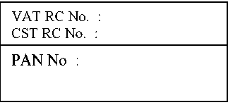
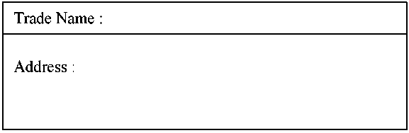

3. Name and Address of the Dealer / person from whom the goods are purchase / imported
3A. Dealer’s Registration No. (TIN)
(if any)

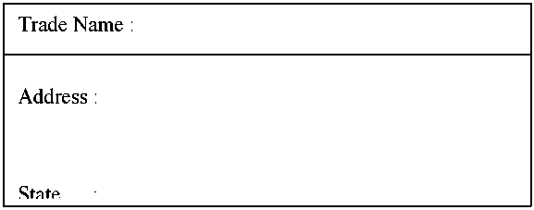
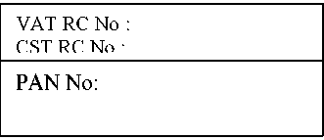

4. Description, Quantity and Value of Goods:
(a)No. of Invoices: (b) Total Value of Goods: Rs.
( in words)

Sl. No. | Commodity | Invoice No. & Date | Quantity | Value of Goods (Rs.)
Sl. No. | Code | Invoice No. & Date | Quantity | Value of Goods (Rs.)
1. | Name
[+ Please use reverse side if the names of commodities exceed 1. ]
5. Name and address of the Transporter / Owner of the Vehicle by which the goods are consigned
5A. Vehicle Number

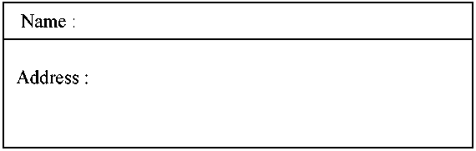
5B. Consignment Note No.

Declaration - *I/We declare that *I/We *am/are registered dealer under the West Bengal Value Added Tax Act, 2003, holding Registration Certificate No. (TIN) . …………………………………. and the statements are correct to the best of my/our knowledge and belief.
Name of the Dealer ………………………………………………………………… Signature of Proprietor/Partner/Authorised person ………………………………… Status/Designation ………………………………………………………………… ..
[ Stamp ]
*Strike out whic he ve r is not applicable

4. Description, Quantity and Value of Goods --- Contd.

Sl. No. | Commodity | Invoice No. & Date | Quantity | Value of Goods (Rs.)
Sl. No. | Code | Invoice No. & Date | Quantity | Value of Goods (Rs.)
2. | Name
3. Code
Name
4. Code

Name
5. Code

Name
Name of the Dealer ………………………………………………………………………….. Signature of Proprietor/Partner/Authorised person …………………………………………. Status/Designation ……………………………………………………………………………
[ Stamp ]
Name of the Notified *Place/Station/Area
Date Month Year Date of Endorsement
Signature of endorsing Sales Tax Officer./ Asstt. Sales Tax Officer ……………….………

